In this test, you have to prepare 3 specifications with 3-3 test cases, the reduction tables and small algorithms using the specification tool and the structogram tool. Prepare the solutions based on the patterns.
In the postcondition (of the specification), you should use the short form - and the algorithm needs to follow your specification.
Please look after the good, readable quality of your work.
There are 90 minutes available. For a good solution a maximum of 100 points could be reached. Don’t forget your name and Neptun-code! During work you are not allowed to talk (chat), to use cell phones, the internet, books, tutorials, ...
Remember! Cheating is not allowed, and action will be taken.
Create a pdf: File/Export/Create a pdf -> Upload in the TMS

Name: <write your name> Neptun code: <your neptun code>

1st task
Dogbert measured the river depth at several locations. Find the largest depth value that is smaller than the depth measured immediately after it. If there is no one, print out –1.

1st example input:  number of locations: 8  depth: [2,4,2,5,6,2,1,7] | Output: 5
2nd example input  number of locations: 4  depth: [2,2,2,2] | Output: -1

Specification
In: n∈N, depth∈N[1..n]
Aux: exists∈L
Out: largestDepth∈Z
Fn: findSmall: N x N[] -> N x N[],
findSmall(n, depth) = MIS(j=1..n-1, depth[j]<depth[j+1], depth[j])
Pre: n>=0 and ∀i∈[1..n]:(depth[i]>=0)
Post: exists = EXISTS(k=1..n-1, depth[k]<depth[k+1]) and
exists -> (,largestDepth) = MAX(i=1..findSmall(n, depth).1, findSmall(n, depth).2[i]) and
not exists -> largestDepth = -1

Link of the specification:
https://progalap.elte.hu/specifikacio/v1/?uuid=392a2c9d-5942-48af-b345-fa94a2f7071f

use SEARCH:
https://progalap.elte.hu/specifikacio/v1/?uuid=8830d0de-065f-4a5c-9814-caf043eda37e

Reduction table:
exists = EXISTS(i=b..e, A(i))
exists ~ exists
i ~ k
b..e ~ 1..n-1
A(i) ~ depth[k]<depth[k+1]

(maxind, maxval) = MAX(i=b..e, f(i))
(maxind, maxval) ~ (,largestDepth)
i ~ i
b..e ~ 1..findSmall(n,depth).1
f(i) ~ findSmall(n, depth).2[i]

(cnt, y) = MIS(i=b..e, A(i), f(i))
(cnt, y) ~ output of findSmall()
i ~ j
b..e ~ 1..n-1
A(i) ~ depth[j]<depth[j+1]
f(i) ~ depth[j]

Test cases:
<Write your test cases (3) in the specification tool. The link of the spec.tool includes then it – but please, copy here, too>
1st test case | 2nd test case | 3rd test case
n: 8  depth: [2, 4, 2, 5, 6, 2, 1, 7]  exists: true  largestDepth: 5 | n: 4  depth: [2, 2, 2, 2]  exists: false  largestDepth: -1 | n: 1  depth: [2]  exists: false  largestDepth: -1

Algorithm
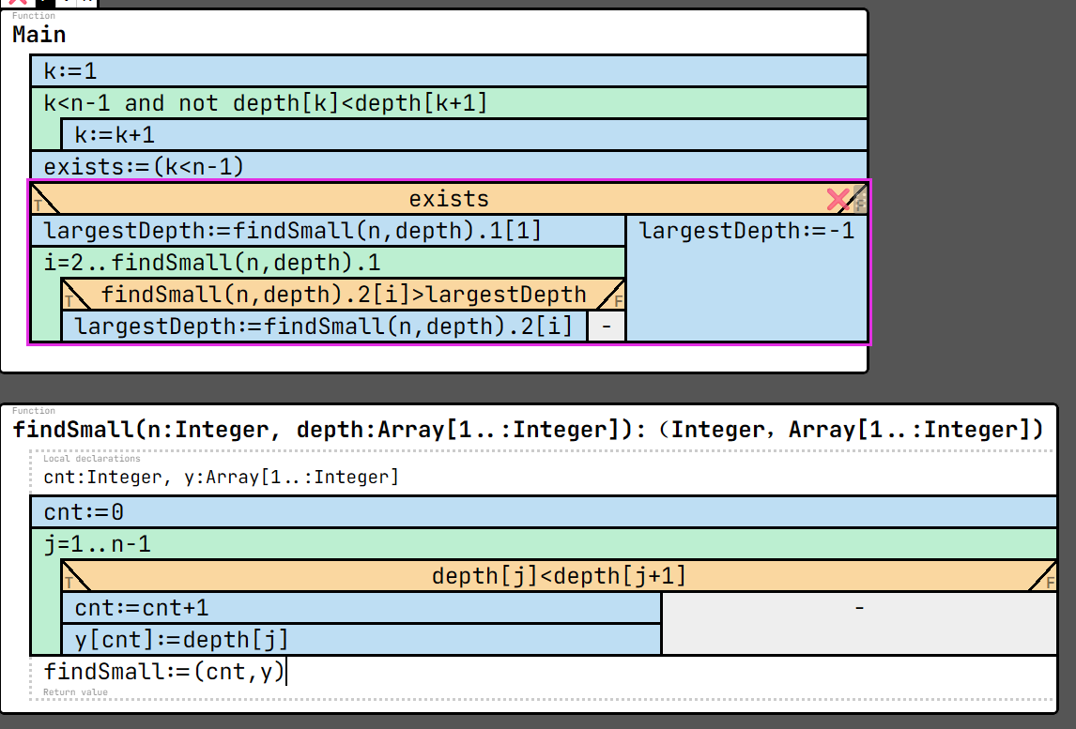

Link of the algorithm:
https://progalap.elte.hu/stuki/v1/?uuid=f1ead8e9-f914-47e7-bcb4-05b37d128c19

2nd task
Catbert recorded the working hours of 'm' colleagues over 'n' days. Find any colleague whose average working time is greater than 'k' hours.

Example input:  n: 5, m: 3, k: 8  1.coll. 2.coll. 3.coll.  1.day 12 2 0  2.day 4 5 1  3.day 1 10 2  4.day 0 12 3  5.day 1 14 1 | Output: 2

Specification
In: n∈N, m∈N, k∈N, workHours∈N[1..n, 1..m]
Aux: exists∈L
Out: greatColl∈N
Fn: average: N -> R,
average(column) = SUM(row=1..n, workHours[row, column]) / n
Pre: n≥0 and m≥0 and ∀i∈[1..n]:(∀j∈[1..m]:(workHours[i,j]≥0))
Post: (exists,greatColl) = SEARCH(column=1..m, average(column)>k)

Link of the specification:
https://progalap.elte.hu/specifikacio/v1/?uuid=09db48ab-e28c-4fd8-afaf-6ef031bef428

Reduction table:
(exists, ind) = SEARCH(i=b..e, A(i))
(exists, ind) ~ (,greatColl)
i ~ column
b..e ~ 1..m
A(i) ~ average(column)>k

s = SUM(i=b..e, f(i))
s ~ -
i ~ row
b..e ~ 1..n
f(i) ~ workHours[row, column]

Test cases:
<Write your test cases (3) in the specification tool. The link of the spec.tool includes then it – but please, copy here, too>
1st test case | 2nd test case | 3rd test case
n: 5  m: 3  k: 8  workHours: [[12, 2, 0],  [ 4, 5, 1],  [ 1, 10, 2],  [ 0, 12, 3],  [ 1, 14, 1]]  exists: true  greatColl: 2 | n: 6  m: 4  k: 6  workHours: [[12, 2, 0, 3],  [ 4, 5, 1, 2],  [ 1, 10, 2, 6],  [14, 12, 3, 7],  [12, 12, 3, 7],  [ 1, 14, 1, 9]]  exists: true  greatColl: 1 | n: 1  m: 4  k: 2  workHours: [[1, 2, 0, 3]]  exists: true  greatColl: 4

Algorithm
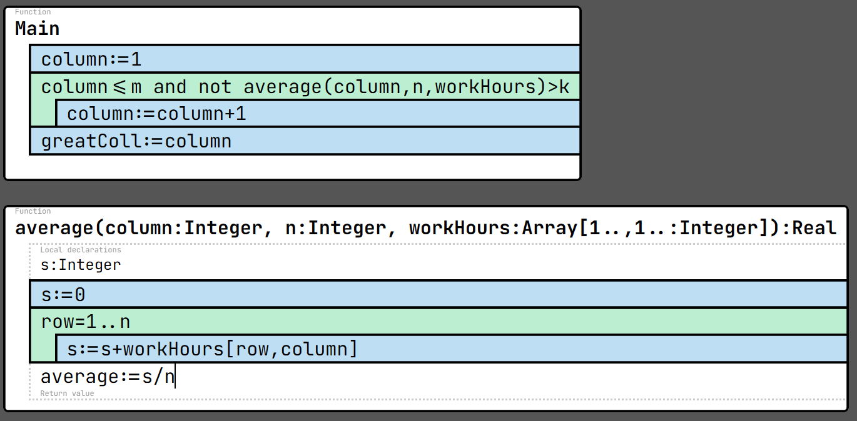

Link of the algorithm:
https://progalap.elte.hu/stuki/v1/?uuid=0885111c-fd63-4ca5-925f-e247f7228a4f

3rd task
Ratbert counted how many times each keyword appears in a code. List the keywords whose counts are greater than the largest count of any keyword that comes before them in the list.
1st example input:  Number of keywords: 5  keywords:  word How many time…  program 1  if 10  else 5  while 20  do 12 | Output: [if, while]

Specification
In: n∈N, keywords∈Tpl[1..n], Tpl=(word:S x times:N)
Aux: cnt∈N
Out: kwlist∈S[]
Fn: isGreater: N -> L,
isGreater(i) = FORALL(j=1..i-1, keywords[j].times < keywords[i].times)
Pre: n>0 and ∀i∈[1..n]:(keywords[i].times≥0)
Post: (cnt, kwlist) = MIS(i=2..n, isGreater(i), keywords[i].word)

Link of the specification:
https://progalap.elte.hu/specifikacio/v1/?uuid=ed18f010-156f-4940-9b07-ea2c1503fd5c

Reduction table:
(cnt, y) = MIS(i=b..e, A(i), f(i))
(cnt, y) ~ (cnt, kwlist)
i ~ i
b..e ~ 2..n
A(i) ~ isGreater(i)

all = FORALL(i=b..e, A(i))
all ~ output of isGreater()
i ~ j
b..e ~ 1..i-1
A(i) ~ keywords[j].times < keywords[i].times
Test cases:
<Write your test cases (3) in the specification tool. The link of the spec.tool includes then it – but please, copy here, too>
1st test case | 2nd test case | 3rd test case
n: 5  keywords: [{word: program, times: 1},  {word: if, times: 10},  {word: else, times: 5},  {word: while, times: 20},  {word: do, times: 12}]  cnt: 2  kwlist: [if, while] | n: 1  keywords: [{word: program, times: 1}]  cnt: 0  kwlist: [] | n: 5  keywords: [{word: program, times: 10},  {word: if, times: 9},  {word: else, times: 8},  {word: while, times: 7},  {word: do, times: 6}]  cnt: 0  kwlist: []

Algorithm

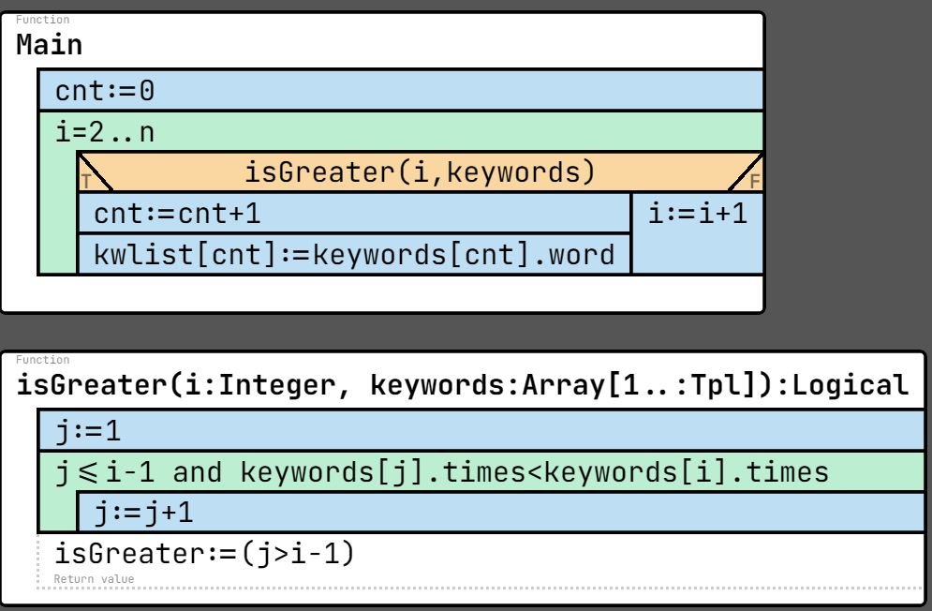

Link of the algorithm:
https://progalap.elte.hu/stuki/v1/?uuid=427f63bd-8779-409f-ae29-901cd384ee7b

